

**Industrial Internship Report on**

**”Digital Marketing”**

**Prepared by**

**[Sakshi Patel ]**

*Executive Summary*

This report provides details of the Industrial Internship provided by upskill Campus and The IoT Academy in collaboration with Industrial Partner Uni Converge Technologies Pvt Ltd (UCT).

This internship was focused on a project/problem statement provided by UCT. We had to finish the project including the report in 6 weeks’ time.

My project was Tell about on Digital marketing is the component of marketing that uses the Internet and online-based digital technologies such as desktop computers, mobile phones, and other digital media and platforms to promote products and services.

This internship gave me a very good opportunity to get exposure to Industrial problems and design/implement solution for that. It was an overall great experience to have this internship.

**TABLE OF CONTENTS**

1-Preface 4

2-Introduction 5

2.1 About UniConverge Technologies Pvt Lt……………………..6-10

2.2 About upskill Campus 11

2.3 Objective 12

2.4 Reference 12

3-Problem Statement 13

3.1 Type of Digital Marketing Channels………………………….14-15

4-Existing and Proposed solution………………………………………16-17

5-Performance Test 18

5.1 Test Plan/ Test Cases 19

5.2 Test Procedure 20

5.3 Performance Outcome 21

6-My learnings 22

7-Future work scope 23

***Acknowledgement***

I hereby express my sincere gratitude and appreciation to upskill Campus and The IoT Academy in collaboration with Industrial Partner Uni Converge Technologies Pvt Ltd (UCT) for providing me with the opportunity to serve as a Digital Marketing Intern. I am writing this acknowledgement to express my heartfelt thanks for the invaluable experience and knowledge I have gained during my internship tenure. First and foremost, I would like to extend my gratitude to the upskill Campus team for their constant support and guidance throughout my internship. I am truly grateful for the trust and confidence they placed in me, allowing me to contribute to various digital marketing projects. Their encouragement and willingness to share their expertise have played a significant role in enhancing my skills and understanding of the digital marketing field. I would also like to express my appreciation to my supervisor and the entire digital marketing team for their patience and mentorship. Their constructive feedback and continuous guidance have been instrumental in my professional growth. Their unwavering support and willingness to answer my questions have made my internship experience both fulfilling and enriching. Furthermore, I would like to extend my thanks to all the colleagues with whom I had the pleasure of working during my internship. Their collaborative spirit and teamwork made the work environment enjoyable and conducive to learning. I am grateful for the opportunities I had to work on various projects alongside such talented individuals.

Sincerely,

Sakshi Patel

***1.Preface***

Provides a concise overview of the digital marketing internship experience, highlighting key aspects and outcomes. The internship focused on gaining practical knowledge and skills in the field of digital marketing, with an emphasis on various strategies, tools, and platforms used in the industry. The objective of the internship was to gain hands-on experience in executing digital marketing campaigns, analyzing data, and contributing to the overall marketing efforts of the organization. During the internship, the intern had the opportunity to work closely with the digital marketing team, receiving guidance and mentorship from experienced professionals. The intern actively participated in planning and implementing digital marketing strategies, including social media marketing, search engine optimization (SEO), content creation, email marketing, and analytics. The internship provided a platform for the intern to explore and learn about different digital marketing channels and techniques. Through practical assignments and projects, the intern gained a deep understanding of target audience segmentation, campaign optimization, and performance tracking. The intern actively contributed to the creation of engaging content, managed social media accounts, conducted keyword research, and analyzed marketing metrics to measure the effectiveness of campaigns.

Keywords: Digital marketing, practical experience, strategies, tools, platforms, social media marketing, SEO, content creation, analytics, skills.

# 

# 2.Introduction

To let the market and customs know about your brand and product, there is no other way than marketing. The more marketing about your product, the more people will know about it. Before 2000, there was no availability of internet, availability of mobiles like today we have. So, people were dependent on newspaper and in some cases television. But now there are thousands of technologies, almost everyone got smartphone. More social media platforms. So, dependency on television decreased. So, people are now digitalized. So, the brands have to promote their business in digital platforms too as people spend more time on social network.

Marketing or promoting business or products on television now has become traditional marketing. Rather than, big brands are now focused on social networks as because they find that digital marketing is helping them to gain more profit rather than old traditional marketing. I am very lucky to work in Solution Hub because they have a very extraordinary creative team and the have some very good local and international brand as client. I got the opportunity to handle those clients and managed some events. I have realized that how to implement the educational knowledge into realistic arena of marketing. In the recent time, digital marketing is a very booming for the brands. Now Bangladeshi advertising agencies are doing great and clients are happy with their stay ices. It's really important to understand the importance of digital marketing rather than the old traditional marketing.

# 2.1About Uni Converge Technologies Pvt Ltd

A company established in 2013 and working in Digital Transformation domain and providing Industrial solutions with prime focus on sustainability and Roi (Return on investment).

For developing its products and solutions it is leveraging various**Cutting Edge Technologies e.g. Internet of Things (IoT), Cyber Security, Cloud computing (AWS, Azure), Machine Learning, Communication Technologies (4G/5G/Lora WAN), Java Full Stack, Python, Front end**etc.

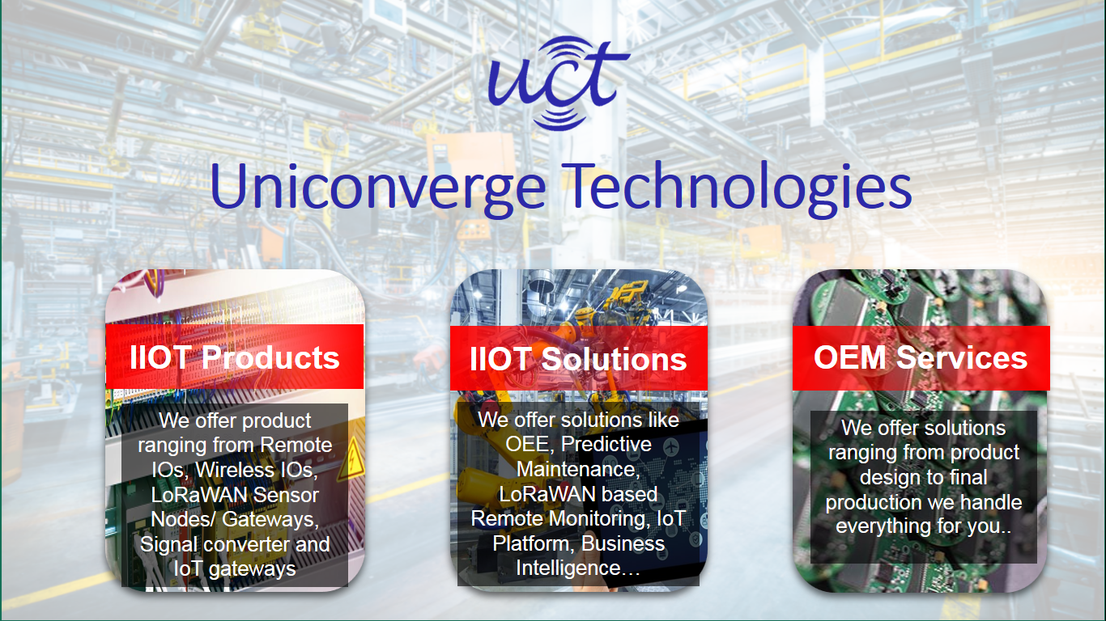

1. UCT IoT Platform **(****)**

**UCT Insight** is an IOT platform designed for quick deployment of IOT applications on the same time providing valuable “insight” for your process/business. It has been built in Java for backend and ReactJS for Front end. It has support for MySQL and various NoSQL Databases.

* It enables device connectivity via industry standard IoT protocols - MQTT, CoAP, HTTP, Modbus TCP, OPC UA
* It supports both cloud and on-premises deployments.

IT Has Features To  
• Build Your own dashboard  
• Analytics and Reporting  
• Alert and Notification  
• Integration with third party application (Power BI, SAP, ERP)  
• Rule Engine





**ii. Smart Factory Platform (****)**

Factory watch is a platform for smart factory needs.

It provides Users/ Factory

* with a scalable solution for their Production and asset monitoring
* OEE and predictive maintenance solution scaling up to digital twin for your assets.
* to unleased the true potential of the data that their machines are generating and helps to identify the KPIs and also improve them.
* A modular architecture that allows users to choose the service that they what to start and then can scale to more complex solutions as per their demands.

Its unique SaaS model helps users to save time, cost and money.

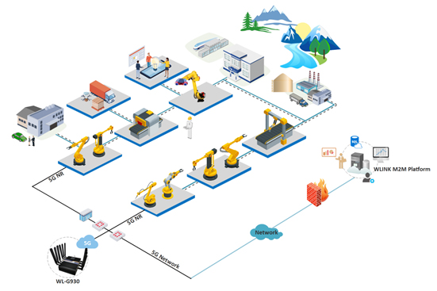



iii.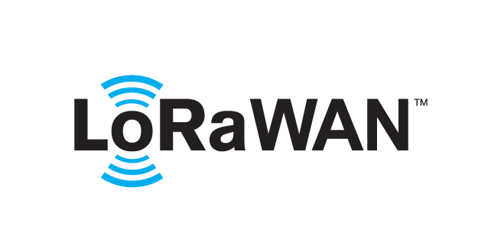 **Based Solution**

UCT is one of the early adopters of Lora WAN technology and providing solution in Aggrotech, Smart cities, Industrial Monitoring, Smart Street Light, Smart Water/ Gas/ Electricity metering solutions etc.

iv. **Predictive Maintenance**

UCT is providing Industrial Machine health monitoring and Predictive maintenance solution leveraging Embedded system, Industrial IoT and Machine Learning Technologies by finding Remaining useful life time of various Machines used in production process.



## 

# 2.2About upskill Campus (USC)

upskill Campus along with The IoT Academy and in association with Unico- verge technologies have facilitated the smooth execution of the complete internship process.

USC is a career development platform that delivers **personalized executive coaching** in a more affordable, scalable and measurable way.





|  |  |
| --- | --- |
| Seeing need of upskilling in self-paced manner along-with additional support services e.g. Internship, projects, interaction with Industry experts, Career growth Services | upskill Campus aiming to upskill 1 million learners in next 5 year |

<https://www.upskillcampus.com/>

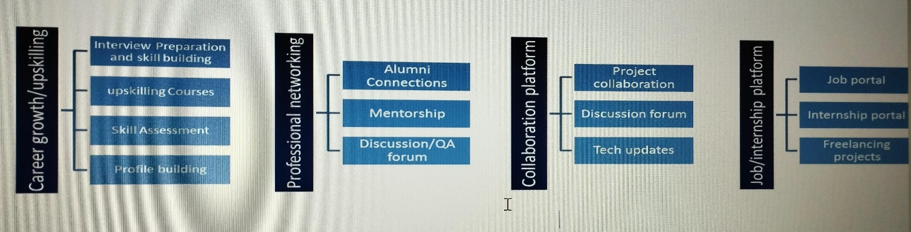

# 2.3 The IoT Academy

The IoT academy is EdTech Division of UCT that is running long executive certification programs in collaboration with EICT Academy, IITK, IITR and IITG in multiple domains.

## Objectives of this Internship program

The objective for this internship program was to

 ☛ get practical experience of working in the industry.

 ☛ to solve real world problems.

 ☛ to have improved job prospects.

 ☛ to have Improved understanding of our field and its applications.

 ☛ to have Personal growth like better communication and problem solving.

## Reference

1. Internet World Stats (2015) World Internet Users Statistics [Online]

http://www.internetworldstats.com/stats.htm

2.Aufray, J., 2009. Master International Business & Marketing, IDRAC Lyon (2009)

3. Stern, C.W. and Deimler, M.S., 2006. The Boston Consultancy Group on Strategy: Classic concepts and new perspectives, John Wiley & Sons.

4. Chaffey, D. and Ellis-Chadwick, F., 2015. Digital Marketing Strategy, Implementation and Practice, 6th edition. Financial Times/ Prentice Hall, Harlow.

3.***Problem Statement***

The internship focused on addressing the challenge of Communicating with the customers in the company. The existing Marketing management had some issues like slow performance, data inconsistency. These problems resulted in reduced operational efficiency, hindered decision-making processes and increased the risk of low costumer rate. For example, Twitter is the social network platform where people share their moments, pictures as well as shared quick messages. In Facebook, brands promote their products and people can comment on that products picture whether it's good or bad but in television, newspaper or radio, when brands promote their products, they only sharing everything on their brands point of view. Customers can't say a word because there iso option. So, brands can know the actual feedback from social network platform rather than television, radio, newspaper. So, in order to stand out from the compaction, brands need to know the actual feedback from their valuable customers.

3.1Type of Digital Marketing Channels

* Website Marketing

A website is the centerpiece of all digital marketing activities. It is a very powerful channel on its own, but it's also the medium needed to execute a variety of online marketing campaigns. A website should represent a brand, product, and service in a clear and memorable way. It should be fast, mobile-friendly, and easy to use.

* Search Engine Optimization (SEO)

SEO, or Search Engine Optimization is the process of getting quality of traffic from free, or organic, search results on the search engines (like google and Bing).

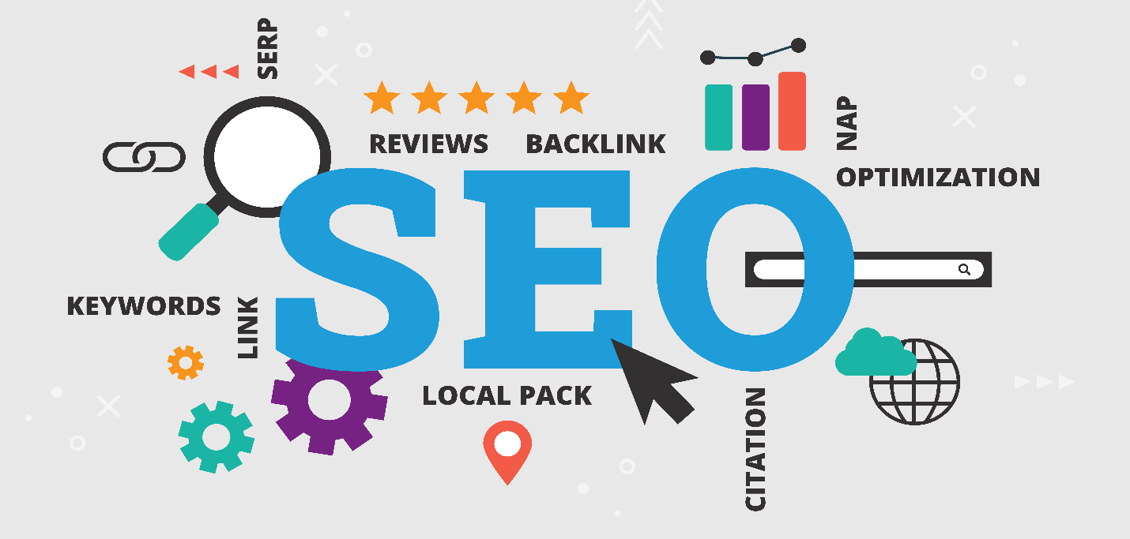

It's important that the traffic you drive to your website is relevant to your industry. If you manage to attract a high volume of visitors searching for Apple computer while what you actually do is selling raincoats, the traffic will do you no-good.

Best Search Engine optimization (SEO)Tools:

* A hrefs: SEO Keyword Tool
* Google Search Console: Top SEO Tool
* KW Finder: SEO Keyword Tool
* Social Media Marketing (SMM)

Simply put, Social media marketing refers to the process of using social media platforms to attract traffic and attention. By using social media, you can increase exposure and build meaningful relationship with your customers.

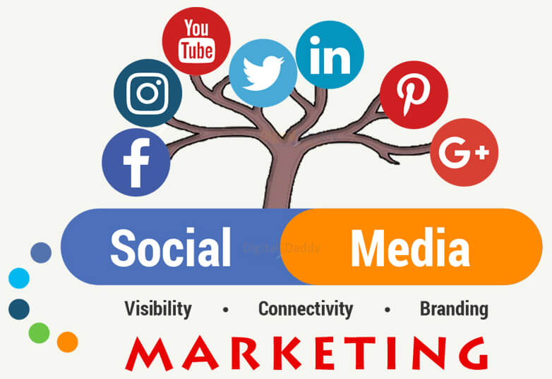

It is important for business to choose the network that supports your brand image. Do not be more social, with your presence on all the social network. Understand your target audience and work accordingly.

**Know the statistics:**

* There are just over 5.35 billion active Internet users (65% of the world's internet users).
* Nearly 5.07 billion people have social media account.
* There are 61.21% Facebook users and 11.59% Instagram users.

# 4.Existing and Proposed solution

Numerous digital marketing solutions exist, each with its strengths and weaknesses. Some common solutions include:

* **Social Media Marketing:** While highly effective for brand awareness and engagement, it can be time-consuming to manage multiple platforms and track ROI.
* **Search Engine Optimization (SEO):** A long-term strategy that can yield significant organic traffic, but it requires technical expertise and consistent effort.
* **Pay-Per-Click (PPC) Advertising:** A fast way to reach a targeted audience, but it can be costly, especially for competitive keywords.
* **Email Marketing:** A cost-effective channel for nurturing leads and driving conversions, but it can be challenging to maintain high open and click-through rates.
* **Content Marketing:** A valuable strategy for building brand authority and attracting organic traffic, but it requires consistent content creation and promotion.

**Proposed Solution: A Comprehensive, AI-Powered Digital Marketing Platform**

To address the limitations of existing solutions, I propose an AI-powered digital marketing platform that combines the best aspects of multiple strategies and offers advanced analytics and automation features. This platform would:

* **Centralize Marketing Efforts:** Consolidate all digital marketing activities, including social media, SEO, PPC, email, and content marketing, into a single, user-friendly dashboard.
* **Leverage AI for Optimization:** Utilize AI algorithms to analyze vast amounts of data and optimize campaigns in real-time, ensuring maximum ROI.
* **Personalize Customer Experiences:** Employ AI-driven personalization techniques to deliver tailored content and offers to each individual customer.
* **Automate Routine Tasks:** Automate repetitive tasks like social media posting, email scheduling, and report generation, freeing up marketers to focus on strategic initiatives.
* **Provide Advanced Analytics:** Offer in-depth analytics to track key performance indicators (KPIs) and gain valuable insights into customer behavior.

**Value Addition**

By combining the power of AI with a comprehensive suite of digital marketing tools, this proposed platform would provide several key benefits:

* **Increased Efficiency:** Automation and streamlined workflows would significantly reduce the time and effort required to manage digital marketing campaigns.
* **Improved ROI:** AI-powered optimization and personalization would lead to higher conversion rates and better return on investment.
* **Enhanced Decision-Making:** Advanced analytics and insights would enable data-driven decision-making, helping businesses make informed choices.
* **Competitive Advantage:** By staying ahead of the curve with cutting-edge technology, businesses could gain a competitive edge in the market.

By addressing the limitations of existing solutions and offering a comprehensive, AI-powered platform, this proposal aims to revolutionize digital marketing and help businesses achieve their goals more effectively.

# 5.Performance Test

Digital marketing campaigns, unlike physical products, don't have the same kind of performance constraints as memory, MIPS, or durability. However, there are still crucial performance factors to consider and test. Here's a breakdown:

**Constraints:**

* **Budget:** Limited budgets can restrict the reach and effectiveness of campaigns.
* **Time:** Tight deadlines may limit the ability to test and optimize campaigns.
* **Technical Knowledge:** Lack of expertise can hinder effective campaign setup and analysis.
* **Data Availability and Quality:** Incomplete or inaccurate data can lead to misleading results.
* **Platform Algorithms:** Evolving algorithms on social media and search engines can impact campaign performance.
* **User Attention:** Short attention spans and information overload can make it difficult to capture and maintain user interest.

**Addressing Constraints in Design:**

* **Budget:** Start with cost-effective tactics like SEO, content marketing, and targeted social media advertising. Focus on high ROI activities.
* **Time:** Prioritize clear, measurable goals and use A/B testing to optimize campaigns efficiently.
* **Technical Knowledge:** Utilize user-friendly platforms and tools, or consider outsourcing aspects requiring specialized skills.
* **Data:** Ensure data collection methods are compliant and focus on collecting relevant, accurate data.
* **Platform Algorithms:** Stay updated on algorithm changes, adjust strategies accordingly, and diversify channels to avoid dependence on one platform.
* **User Attention:** Create engaging and concise content, utilize compelling visuals, and personalize the user experience.

**Testing and Recommendations:**

* **Campaign performance metrics:** Track key metrics like website traffic, conversion rates, engagement, and cost per acquisition (CPA).
* **A/B testing:** Test different variations of ad copy, landing pages, and calls to action to see what resonates best with your audience.
* **Benchmarking:** Compare your performance against industry averages and competitor data to identify areas for improvement.

**Even if extensive testing isn't possible:**

* **Develop a realistic budget:** Allocate resources strategically to maximize reach.
* **Set SMART goals:** Specific, Measurable, Achievable, Relevant, and Time-bound to track progress.
* **Utilize analytics tools:** Monitor key metrics to identify trends and adapt strategies.
* **Stay informed:** Keep up with digital marketing trends and best practices.

By focusing on these aspects, you can design digital marketing campaigns that are effective within your constraints and deliver measurable results. Remember, successful digital marketing is an ongoing process of learning, adapting, and optimizing based on performance data.

**5.1 Test Plan/Test Cases**

**Objective:** To assess the performance of a digital marketing campaign and identify areas for improvement.

**Test Cases:**

1. **Website Traffic:**
   * **Test Case 1.1:** Measure website traffic (unique visitors, page views, and session duration) before and after the campaign.
   * **Test Case 1.2:** Analyze the source of traffic (organic, paid, social media, etc.) to identify the most effective channels.
2. **Conversion Rate:**
   * **Test Case 2.1:** Calculate the conversion rate (number of conversions divided by the number of visitors) for key actions (e.g., purchases, sign-ups, form submissions).
   * **Test Case 2.2:** Compare the conversion rates of different landing pages, ad creatives, or email subject lines.
3. **Engagement Metrics:**
   * **Test Case 3.1:** Measure social media engagement (likes, shares, comments) on posts and ads.
   * **Test Case 3.2:** Analyze email open and click-through rates.
4. **Cost-Per-Acquisition (CPA):**
   * **Test Case 4.1:** Calculate the CPA for different marketing channels to determine the most cost-effective strategies.
5. **Return on Investment (ROI):**
   * **Test Case 5.1:** Calculate the ROI of the campaign by comparing the total revenue generated to the total cost.

**5.2 Test Procedure**

1. **Data Collection:**
   * Gather data from various sources, including website analytics, social media platforms, email marketing tools, and paid advertising platforms.
2. **Data Analysis:**
   * Use appropriate statistical methods (e.g., t-tests, ANOVA, correlation analysis) to analyze the data.
   * Visualize the data using charts and graphs to identify trends and patterns.
3. **Performance Metrics Calculation:**
   * Calculate key performance metrics (e.g., website traffic, conversion rates, engagement, CPA, ROI).
4. **A/B Testing:**
   * Conduct A/B tests to compare different variations of marketing materials (e.g., ad copy, landing pages, email subject lines).

**5.3 Performance Outcome**

The performance outcome will vary depending on the specific goals and objectives of the campaign. However, some common performance metrics to track include:

* **Website Traffic:** Increased website traffic from target audience segments.
* **Engagement:** Improved engagement on social media and email campaigns.
* **Cost-Per-Acquisition (CPA):** Lower CPA for acquiring new customers.
* **Return on Investment (ROI):** Positive ROI, indicating a profitable campaign.

By analyzing these metrics, you can identify successful strategies, areas for improvement, and inform future marketing efforts.

# 6.My learnings

During the internship, I gain insights about different tools and techniques of Digital Marketing. I will work with the latest technology. I work on live projects which will give you a feel of a real job that how is it processed in an industry. I also learn about different digital marketing vertex such as SEO, paid ads through SEM, SMM and many more. I can show you creativity and know what is there in you which was hidden.

As a digital marketing intern, I am learning outcomes will be instrumental in shaping your growth and development in the field. Throughout my internship, I have the opportunity to acquire valuable knowledge and skills that will empower you in your digital marketing career. I gain a deep understanding of various digital marketing strategies, such as social media marketing, content creation, search engine optimization (SEO), email marketing, and online advertising. By actively participating in executing digital campaigns, I strengthen my proficiency in utilizing essential tools and platforms. Through hands-on experience, I can develop a keen ability to analyze data and derive meaningful insights to optimize campaign performance. As I collaborate with professionals in the industry, I can enhance teamwork and communication skills, fostering an environment conducive to personal and professional growth. Overall, my internship as a digital marketing intern will serve as a springboard for my future endeavors, equipping you with the expertise and confidence to excel in the dynamic world of digital marketing.

**Performance testing is a cornerstone of successful digital marketing. By systematically analyzing key metrics like website traffic, conversion rates, engagement, and ROI, marketers can identify areas for improvement, optimize campaigns, and make data-driven decisions. This skill not only enhances campaign performance but also positions professionals for career advancement by demonstrating expertise in data analysis, A/B testing, and digital marketing technologies. As the digital landscape continues to evolve, mastering performance testing is essential for staying ahead of the curve and driving impactful results.**

# 7.Future work scope

While we've covered the basics of performance testing, there's a vast landscape of advanced techniques and emerging trends to explore. These include load, stress, spike, and soak testing to identify system limitations. Additionally, AI and machine learning can revolutionize performance testing by automating tasks, enabling predictive analytics, and personalizing marketing efforts. As the digital landscape evolves, marketers should embrace emerging trends like voice search optimization, AR/VR, and programmatic advertising to stay competitive and deliver exceptional results.